Ryan P. O’Quinn, MD
Joshua L. Owen, MD, PhD
Courtney S. Aldridge, PA-C

Centralized Scheduling (210) 558-6234
Centralized Fax (210) 446-5039

[ ] Ryan P. O’Quinn, MD [ ] Joshua L. Owen, MD, PhD [ ] Courtney Aldridge, PA-C
NPI: 1205881281 NPI: 1154717726 NPI: 1205966819

Group Tax ID: 47-0851901
Centralized Scheduling: (210) 558-6234
Centralized Fax: (210) 446-5039

Please FAX the Following:
- REFERRAL REQUEST FORM
- INSURANCE REFERRAL AUTHORIZATION
- PROGRESS NOTES
- PATH REPORT
- PATIENT DEMOGRAPHICS AND INSURANCE

CLINIC LOCATIONS:

2632 Broadway, Suite 300 South
San Antonio, TX 78215
(Consults, Office Visits & Mohs Procedures)
9238 Floyd Curl, Suite 101
San Antonio, TX 78240
(Consults, Office Visits & Mohs Procedures)

813 Paris
Castroville, TX 78009
(Consults, Office Visits & Mohs Procedures)

Common Referral Codes for Mohs: Referral Codes for Other Dermatology Visits:
99203/99214 PLUS the Following CPT Codes: 99203/99214 PLUS 11102/11104 AND 17000
17311 and 17312 for Head, Neck, Hands, Feet, Genitalia
17313 and 17314 for Trunk, Arms, Legs Common ICD-10 Dermatology Codes:
AND Repair Codes: Skin Lesion- D48.5 Rash- L30.9 Acne- L70.9
Face: 13132, 13152, 14041, 14061, 15240, 15260 Psoriasis- L40.0 Alopecia- L65.9 BCC- C44.xxx
Trunk/extremities: 13101, 13121, 14021, 15220 SCC- C44.xxx Melanoma- C43.xxx Melanoma In Situ- D03.xxx

Location
[ ] 2632 Broadway
Suite 300 South
San Antonio, TX 78215

[ ] 9238 Floyd Curl
Suite 101
San Antonio, TX 78240

[ ] 813 Paris
Castroville, TX 78009

Provider
[ ] First Available Physician

[ ] Ryan P. O’Quinn, MD
NPI: 1205881281

[ ] Joshua L. Owen, MD, PhD
NPI: 1154717726

[ ] Courtney Aldridge, PA-C
NPI: 1205966819

Group Tax ID:
47-0851901

OFFICE (210) 558-6234
FAX: (210) 446-5039

Please FAX the Following:
- REFERRAL REQUEST FORM
- INSURANCE REFERRAL AUTHORIZATION
- PROGRESS NOTES
- PATH REPORT
- PATIENT DEMOGRAPHICS AND INSURANCE

- REFERRAL REQUEST FORM
- INSURANCE REFERRAL AUTHORIZATION
- PROGRESS NOTES
- PATH REPORT
- PATIENT DEMOGRAPHICS AND INSURANCE

Please Fax Referral Request Form to (210) 446-5039
Patient Name: __________________________________________________________________________________________________
Address: ____________________________________________________________________________________________
City, State, Zip: ________________________________________________________________________________________________
SSN: ________--________--________ DOB: ________/________/________
Home Phone: (_____) __________-_________ Mobile Number: (_____) _______-__________
Email: ___________________________________ [ ] Male [ ] Female
INSURANCE:
PRIMARY: _______________________________________ Policy #: _______________________________________
Group #: ________________________________________ Policy Holder: _________________________________
Subscriber DOB: _______/________/________ Subscriber SSN: ___________-_______-___________
SECONDARY: _______________________________________ Policy #: _______________________________________
Group #: ________________________________________ Policy Holder: _________________________________
Subscriber DOB: _______/________/________ Subscriber SSN: ________-_________-___________
Referring Physician: _____________________________________ Physician NPI#: __________________________
Your Patient has been scheduled for:
DATE: _____/_____/______
Time: _______ AM / PM
[ ] Our Office has notified Patient of the appointment
Contact Person @ your office for this Referral: ________________________ Phone (_______) ______-_________
Fax: (_____) _______-____________ CPT Codes: Evaluate & Treat ________________________________
CPT Code: ________________________________________________
Diagnosis for Referral: __________________________ ICD 10 Code: ___________________
Authorization Number (if applicable): _______________________________________________________________________
Total Visits Authorized: _________________________ Start Date: _____/_____/______ Expires: _______/_______/_______
(PATIENT COPY)
Patient Instructions:
- Please arrive 20 minutes prior to appointment time in order to finalize registration.
- A picture ID and your insurance card are required at the time of appointment registration.
- Copayment responsibilities are due at time of your registration.
2632 Broadway, Suite 300 South 9238 Floyd Curl, Suite 101
San Antonio, TX 78215 San Antonio, TX 78240
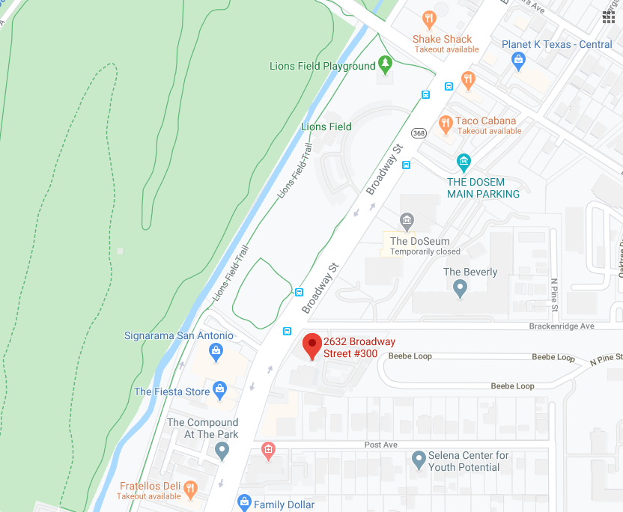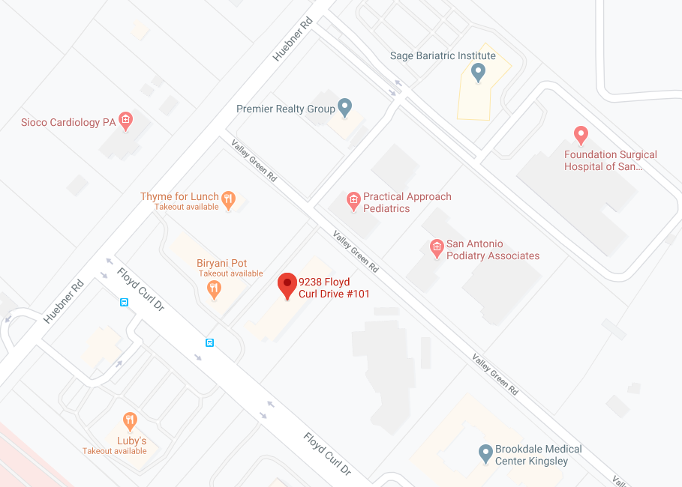
813 Paris, Castroville, TX 78009
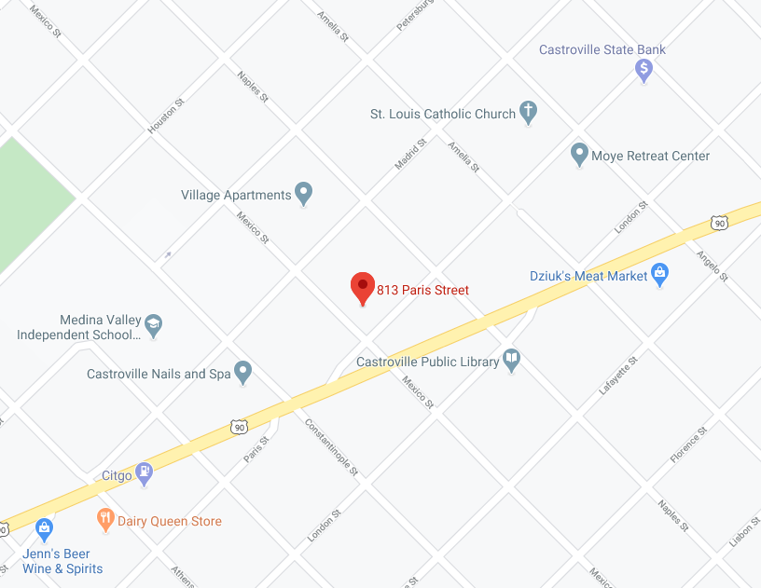
CENTRALIZED APPOINTMENTS: (210) 558-6234

